

**Department of Computer Science & Engineering**

**CERTIFICATE**

This is to certify that the work embodies in this Project entitled “**Doctor Appointment Application**” being submitted by “**Amit Kumar Saini(18EARIT007), Jitesh Sharma(18EARIT027), Divyanshu Mishra(18EARIT020) ”** in partial fulfillment of the requirement for the award of“**Bachelor of Technology in Information Technology & Engineering”** to Rajasthan Technical University, Kota (Raj.) during the academic year 2020-21 is a record of bonafide piece of work, carried out by them under our supervision and guidance in the **“Department** **of Computer Science &** **Engineering”, Arya College of Engineering & Information Technology, Jaipur**.

|  |  |
| --- | --- |
| Project Guide | Project-coordinator |
| **Er. Rakesh Ranjan** | **Dr. Vibhakar Pathak** |
| **Professor** | **Professor** |

Approved by

**Dr. Akhil Pandey**

Head, Department of

Computer Science & Engineering



**Department of Computer Science & Engineering**

**CERTIFICATE OF APPROVAL**

The Major Project Report entitled “**Doctor Appointment Application**” being submitted by “**Amit Kumar Saini(18EARIT007), Jitesh Sharma(18EARIT027), Divyanshu Mishra(18EARIT020)”** has been examined by us and is hereby approved for carrying out the project leading to the award of degree “**Bachelor of** **Technology in Information Technology & Engineering”**. By this approval theundersigned does not necessarily endorse or approve any statement made, opinion expressed or conclusion drawn therein, but approve the pursuance of project only for the above mentioned purpose.

|  |  |
| --- | --- |
| Project Guide | Project Coordinator |
| **Er. Rakesh Ranjan** | **Dr. Vibhakar Pathak** |
| **Professor** | **Professor** |



**Department of Computer Science & Engineering**

**DECLARATION**

We “**Amit Kumar Saini, Jitesh Sharma, Divyanshu Mishra**”, studentsof **Bachelor of Technology** in **Information Technology & Engineering, session 2021-22, Arya College of Engineering & Information Technology, Jaipur**, here by declare that the work presentedin this Project entitled “**Doctor Appointment Application**” is the outcome of our own work, is bonafide and correct to the best of our knowledge and this work has been carried out taking care of Engineering Ethics. The work presented does not infringe any patented work and has not been submitted to any other University or anywhere else for the award of any degree or any professional diploma.

Amit Kumar Saini (18EARIT007)

Jitesh Sharma (18EARIT027)

Divyanshu Mishra (18EARIT020)

Date : 11-06-2022

**ACKNOWLEDGEMENT**

I would like to express my sincere and profound gratitude to our project coordinator **Dr. Vibhakar Pathak** sir for his simulating guidance, continuous encouragement and supervisionthroughout the course of present work.

I would like to place on record my deep sense of gratitude to our project guide **Er. Rakesh Ranjan** sir for his generous guidance, help and useful suggestions.

I also wish to extend my thanks to Head of CS/IT Department **Dr. Akhil Pandey** sir for his insightful comments and constructive suggestions to improve the quality of this project.

I am extremely thankful to the whole CS/IT Department for providing us infrastructural facilities to work in, without which this work would not have been possible.

**ABSTRACT**

As we have seen the hard times of covid the problem of appointments as well as the problem of overcrowding in small clinics and hospitals is very high and these problems are very much seen in the rural and sub- urban areas so to solve this problem we have come up with an application through which user can book appointments online which saves time and reduce monetary loss of the user that is patient and doctor as well.

The solution to this problem is given by us through our application which is android based through which a patient that is a user can book the appointment online and the doctor can see how many patients have booked the appointment and this all can be controlled through the application only which results in reduction of overcrowding and reduce the loss of time and other monetary losses.

**TABLE OF CONTENTS**

* Objective & Scope of the Project…………………………………..……………….7-8
* Theoretical Background………………………………………………….…..……...9
* Definition o Problem……………………………………………..……..…………..10
* System Analysis & User Requirements……………………………………………..11
* Methodology Used…………………………………………………..…….………..12
* ERD, DFD……………………………………………………….…….….……..13-15
* Input and Output Screen Design………………………………………………….16-17
* Code Sheets……………………………………………………………………....18-43
* Testing……………………………………………………………………………….44
* User/Operational Manual …………………………….……………………………..45
* Conclusions………………………………………………………………………….46
* Future enhancement………………………………………….……………………....47
* References…………………………………………..………………………………48

**CHAPTER – 1**

**OBJECTIVE AND SCOPE OF PROJECT**

The current standard operating procedure in healthcare environment for patient registration and appointment scheduling are time consuming and somehow troublesome. Medical Appointment Application is a web-based mobile application develop for managing appointment-booking process for a few medical organizations, regardless of the type of service they schedule in Parit Raja and Batu Pahat area. The practices will have to sign up on the online appointments portal themselves and can view the appointment made by user, the patients. It will help user, the

patients to book their appointment using the Medical Appointment application. Furthermore, Prototype Model is used to develop this system. As for the hardware and software used to develop this system is MySQL Database and programming language use is PHP and JavaScript. By developing this system, it will reduce the number of calls for an appointment and avoid the morning rush for an urgent appointment. Also, it will potentially reduce the need for

extra reception staff, a significant reduction in labor. Furthermore, it helps user in time saving and avoiding the need to negotiate with the receptionist for a convenient appointment time. This technology can transform the current daunting appointment process and enable them to run more efficiently, effectively and profitably. The scheduling of appointments and reservations is an important task in the operations of all sized organizations, from companies and enterprise corporations, right down to service-based small businesses. While the manner of appointment-scheduling has evolved through the years, from taking appointments over the phone and recording them in a paper appointment book to utilizing an electronic calendar such as those offered

by Google or Microsoft Outlook, the task itself remains tedious and timeconsuming for organizations that continue to rely on these outdated and inefficient methods. Medical appointment is a meeting between a patient with a physician or doctor to get health advice or treatment for a symptom or condition. Appointments are strongly encouraged so that Medical Services staff may be sensitive to any time constraints. It is also helpful if patients provide basic information about the reason of their intended visit (e.g., stomach pains, headache, travel assessment, pregnancy screening, and prescription refill). Patients can make appointments with their desire clinic or hospital 24/7 with the doctor of their choice, easing the pressure on the reception and the phone system. Medical Appointment is a web-based mobile application design to help in patient scheduling. Patient scheduling is an integral part of daily work for healthcare professionals, from family practices to large clinics, from physician offices to hospitals. Appointments need to be coordinated and medical support staff has to be constantly aware of all new patients and doctor’s schedule. Before discussing the aspects showing the importance of customized mobile apps for the healthcare sector, let us go through an interesting fact: As per an official survey, the mHealth (mobile Health) solutions market is expected to reach $90. 49 billion by 2022. It shows the growing interest of the healthcare services providers to take a mobile route to offer more convenience to the patients. The mobile application development company can provide all the benefits through customized mobile apps. These days, as people become more health-conscious than ever, and the lifestyle-related diseases are on the rise, the mobile app can play a significant role in many aspects. For example, the health mobile app enables the patients to get an access to their health data anytime and anywhere. Also, patients can also share the data with the healthcare specialist. On the other hand, the healthcare professionals get rid of maintaining and accessing the printed data as a reference. In a way, the tailored healthcare mobile app can bring a paradigm shift from print and laptop-based data to mobile-based data.

Also, the healthcare sector is broadly based on the patient-doctor interaction. The mobile app connects them instantly while blurring the boundaries of countries. Doctors can also communicate securely with other doctors to share the important information thanks to a customized healthcare mobile app.

In brief, the mobile apps for healthcare sector can digitize the entire process and enable the healthcare companies to serve the patients in a better way.

**CHAPTER – 2**

**THEORETICAL BACKGROUND**

First of all, we assess a clinic and it needs according to which we made this application which consists of appointment and emergency priority of the patient which helps in reducing the overcrowding and monetary losses of the patients.

Then we thought of this problem and how to solve it then we thought to make a web application about appointments and services web applications are much more complex and hard to use for the rural areas so then we come up with the mobile application to make it more accessible and easy to use.

**CHAPTER – 3**

**DEFINITION OF PROBLEM**

As we have seen the hard times of covid the problem of appointments as well as the problem of overcrowding in small clinics and hospitals is very high and these problems are very much seen in the rural and sub- urban areas so to solve this problem we have come up with an application through which user can book appointments online which saves time and reduce monetary loss of the user that is patient and doctor as well.

Solution:

The solution to this problem is given by us through our application which is android based through which a patient that is a user can book the appointment online and the doctor can see how many patients have booked the appointment and this all can be controlled through the application only which results in reduction of overcrowding and reduce the loss of time and other monetary losses.

**CHAPTER – 4**

**System Analysis & Requirement**

Android Studio : Android Studio is the official integrated development environment (IDE) for Google's Android operating system, built on JetBrains' IntelliJ IDEA software and designed specifically for Android development. It is available for download on Windows, macOS and Linux based operating systems or as a subscription-based service in 2020 It is a replacement for the Eclipse Android Development Tools (EADT) as the primary IDE for native Android application development.

Firebase : Firebase evolved from Envolve, a prior startup founded by James Tamplin and Andrew Lee in 2011. Envolve provided developers an API that enables the integration of online chat functionality into their websites. After releasing the chat service, Tamplin and Lee found that it was being used to pass application data that were not chat messages. Developers were using Envolve to sync application data such as game state in real time across their users. Tamplin and Lee decided to separate the chat system and the real-time architecture that powered it. They founded Firebase as a separate company in 2011 and it launched to the public in April 2012.Firebase's first product was the Firebase Realtime Database, an API

 that synchronizes application data across iOS, Android, and Web devices, and stores it on Firebase's cloud. The product assists software developers in building real-time, collaborative applications.

Android Emulator : The Android Emulator simulates Android devices on your computer so that you can test your application on a variety of devices and Android API levels without needing to have each physical device.The emulator provides almost all of the capabilities of a real Android device. You can simulate incoming phone calls and text messages, specify the location of the device, simulate different network speeds, simulate rotation and other hardware sensors, access the Google Play Store, and much more.

Testing your app on the emulator is in some ways faster and easier than doing so on a physical device. For example, you can transfer data faster to the emulator than to a device connected over USB. The emulator comes with predefined configurations for various Android phone, tablet, Wear OS, and Android TV devices

**CHAPTER – 5**

**Methodology adopted & details of hardware and software**

Appointments are made easy which can be done online through the app and the emergency cases can be handled on a priority basis.

Android Studio : Android Studio is the official integrated development environment (IDE) for Google's Android operating system, built on JetBrains' IntelliJ IDEA software and designed specifically for Android development. It is available for download on Windows, macOS and Linux based operating systems or as a subscription-based service in 2020 It is a replacement for the Eclipse Android Development Tools (EADT) as the primary IDE for native Android application development.

Firebase : Firebase evolved from Envolve, a prior startup founded by James Tamplin and Andrew Lee in 2011. Envolve provided developers an API that enables the integration of online chat functionality into their websites. After releasing the chat service, Tamplin and Lee found that it was being used to pass application data that were not chat messages. Developers were using Envolve to sync application data such as game state in real time across their users. Tamplin and Lee decided to separate the chat system and the real-time architecture that powered it. They founded Firebase as a separate company in 2011 and it launched to the public in April 2012. Firebase's first product was the Firebase Realtime Database, an API that synchronizes application data across iOS, Android, and Web devices, and stores it on Firebase's cloud. The product assists software developers in building real-time, collaborative applications.

Android Emulator : The Android Emulator simulates Android devices on your computer so that you can test your application on a variety of devices and Android API levels without needing to have each physical device.The emulator provides almost all of the capabilities of a real Android device. You can simulate incoming phone calls and text messages, specify the location of the device, simulate different network speeds, simulate rotation and other hardware sensors, access the Google Play Store, and much more.

Testing your app on the emulator is in some ways faster and easier than doing so on a physical device. For example, you can transfer data faster to the emulator than to a device connected over USB. The emulator comes with predefined configurations for various Android phone.

**CHAPTER – 6**

**DFD Diagram & ERD Diagram**

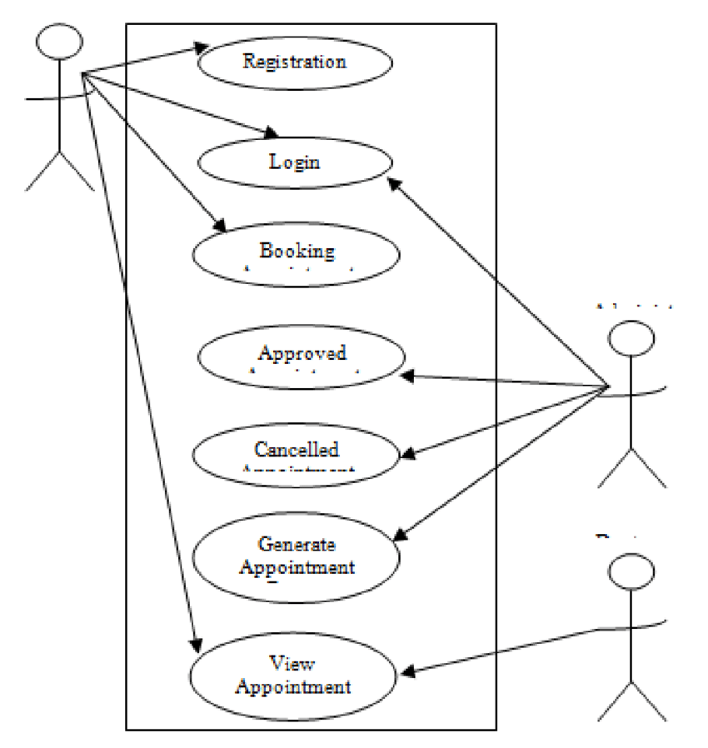

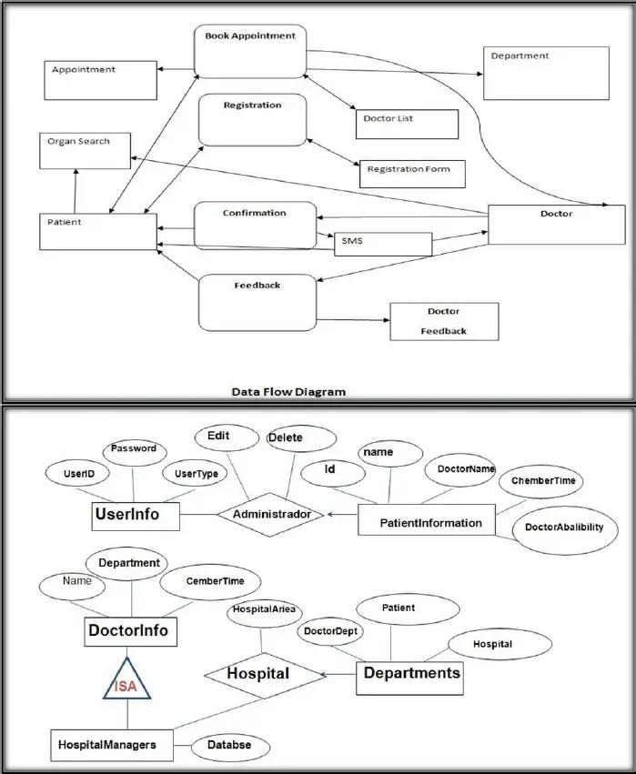

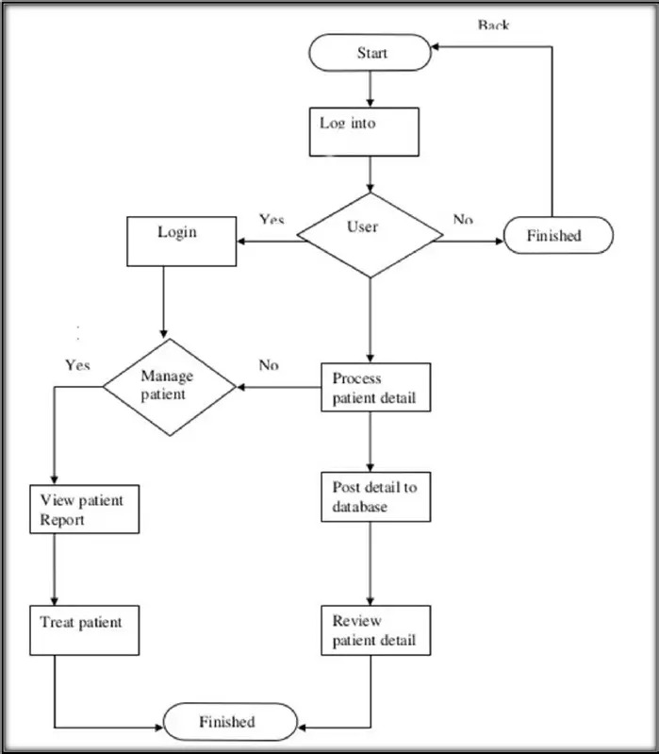**ERD Diagram**

**CHAPTER - 7**

**Input And Output Screen Design**

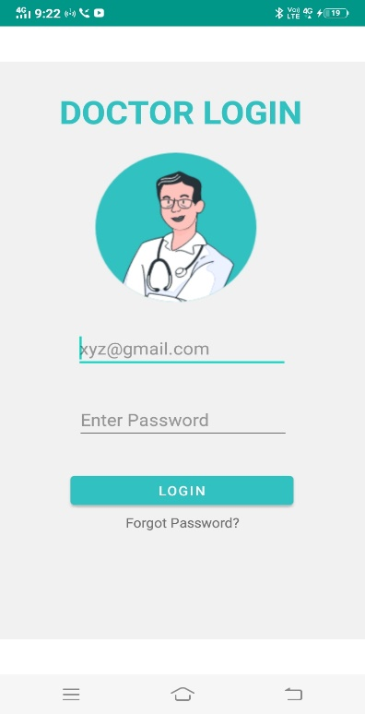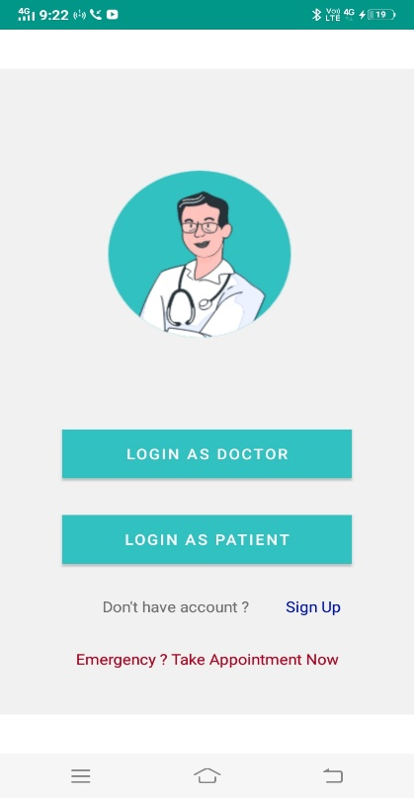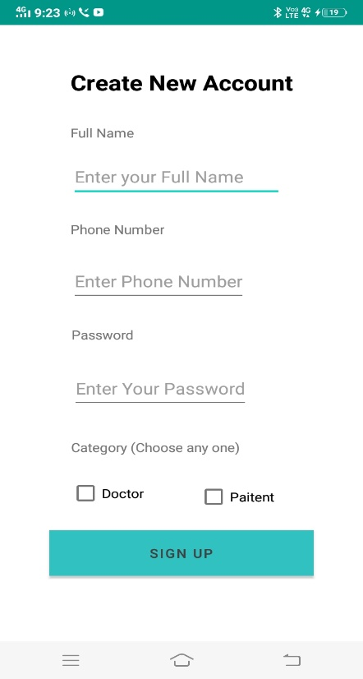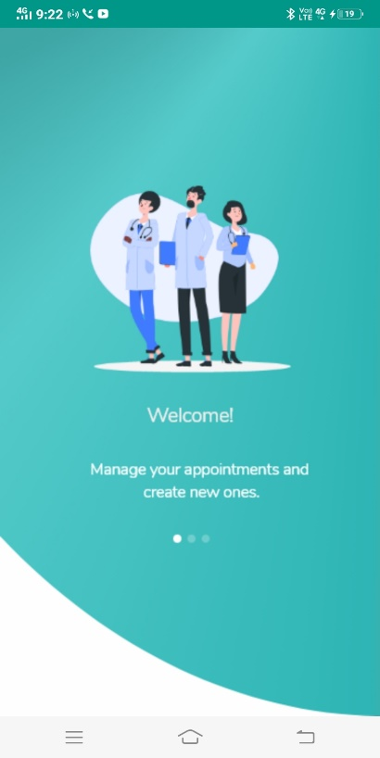

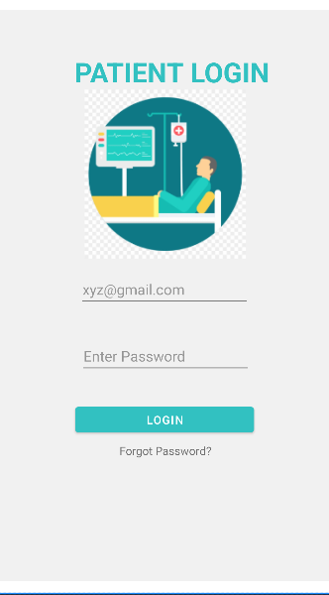

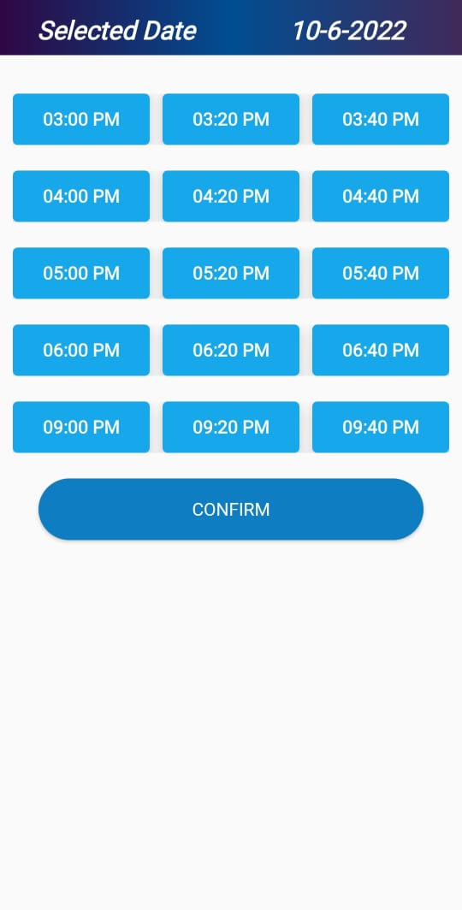

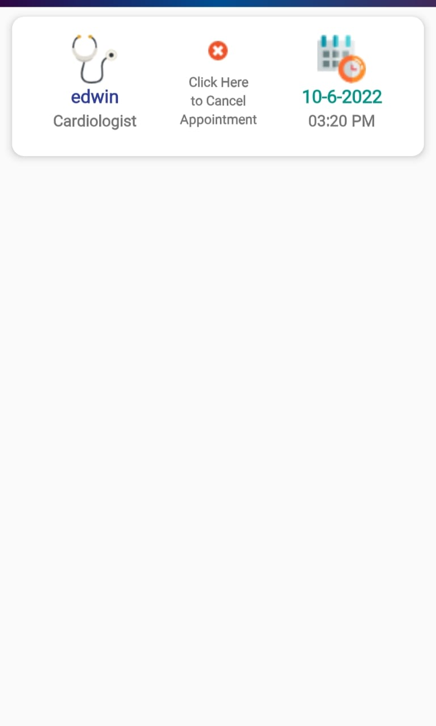

**CHAPTER - 8**

**Coding Sheets**

**Main Activity**

package com.example.lifecareclinic;  
  
import androidx.appcompat.app.AppCompatActivity;  
  
import android.content.Intent;  
import android.os.Bundle;  
  
import java.util.Timer;  
import java.util.TimerTask;  
  
public class MainActivity extends AppCompatActivity {  
  
 Timer timer;  
  
 @Override  
 protected void onCreate(Bundle savedInstanceState) {  
 super.onCreate(savedInstanceState);  
 setContentView(R.layout.activity_main);  
 timer = new Timer();  
 timer.schedule(new TimerTask() {  
 @Override  
 public void run() {  
 Intent intent= new Intent(MainActivity.this, LoginPanel.class);  
 startActivity(intent);  
 finish();  
  
 }  
 },3000);  
 }  
}

**Tab Page**

package com.example.lifecareclinic;  
  
import androidx.appcompat.app.AppCompatActivity;  
  
import android.content.Intent;  
import android.os.Bundle;  
import android.view.View;  
import android.widget.Button;  
import android.widget.ImageView;  
  
public class TabPage extends AppCompatActivity implements View.OnClickListener {  
  
 public ImageView doctor,AboutUs, appointment;  
  
  
  
 @Override  
 protected void onCreate(Bundle savedInstanceState) {  
 super.onCreate(savedInstanceState);  
 setContentView(R.layout.activity_tab_page);  
  
 doctor = (ImageView) findViewById(R.id.DoctorButton);  
 AboutUs = (ImageView) findViewById(R.id.AboutButton) ;  
 appointment = (ImageView) findViewById(R.id.AppointmentButton);  
  
 doctor.setOnClickListener(this);  
 AboutUs.setOnClickListener(this);  
 appointment.setOnClickListener(this);  
  
 }  
  
 @Override  
 public void onClick(View v) {  
 Intent intent;  
 switch (v.getId()){  
 case R.id.DoctorButton:  
 intent = new Intent(this,DoctorTab.class);  
 startActivity(intent);  
 break;  
  
 case R.id.AboutButton:  
 intent = new Intent(this,AboutUsTab.class);  
 startActivity(intent);  
 break;  
  
 case R.id.AppointmentButton:  
 intent = new Intent(this,AppointmentTab.class);  
 startActivity(intent);  
 break;  
  
 }  
  
 }  
}

**Login Panel**

package com.example.lifecareclinic;  
  
import androidx.appcompat.app.AppCompatActivity;  
  
import android.content.Intent;  
import android.os.Bundle;  
import android.view.View;  
import android.widget.Button;  
import android.widget.TextView;  
  
public class LoginPanel extends AppCompatActivity implements View.OnClickListener {  
 public Button loginAsDoctor, loginAsPaitent;  
 public TextView signUp;  
  
  
 @Override  
 protected void onCreate(Bundle savedInstanceState) {  
 super.onCreate(savedInstanceState);  
 setContentView(R.layout.activity_login_panel);  
  
 loginAsDoctor = (Button) findViewById(R.id.LoginAsDoctor);  
 loginAsPaitent = (Button) findViewById(R.id.LoginAsPaitent);  
 signUp = (TextView) findViewById(R.id.SignUp);  
  
 loginAsDoctor.setOnClickListener(this);  
 loginAsPaitent.setOnClickListener(this);  
 signUp.setOnClickListener(this);  
  
 }  
  
  
 @Override  
 public void onClick(View v) {  
 Intent i;  
 switch (v.getId()){  
 case R.id.LoginAsDoctor:  
 i = new Intent(this,DoctorLogin.class);  
 startActivity(i);  
 break;  
 case R.id.LoginAsPaitent:  
 i = new Intent(this,PaitentLogin.class);  
 startActivity(i);  
 break;  
 case R.id.SignUp:  
 i = new Intent(this,SignUp.class);  
 startActivity(i);  
 break;  
 }  
  
 }  
}

**Patient Login**

package com.example.lifecareclinic;  
  
import androidx.appcompat.app.AppCompatActivity;  
  
import android.content.Intent;  
import android.os.Bundle;  
import android.view.View;  
import android.widget.Button;  
  
public class PaitentLogin extends AppCompatActivity {  
  
 private Button button;  
  
 @Override  
 protected void onCreate(Bundle savedInstanceState) {  
 super.onCreate(savedInstanceState);  
 setContentView(R.layout.activity_paitent_login);  
  
 button = (Button) findViewById(R.id.LoginButtonPaitent);  
 button.setOnClickListener(new View.OnClickListener() {  
 @Override  
 public void onClick(View v) { openTabPage();  
  
 }  
 });  
 }  
 public void openTabPage(){  
 Intent intent = new Intent(this, TabPage.class);  
 startActivity(intent);  
 }  
}

**Welcome Screen XML Code**

<?xml version="1.0" encoding="utf-8"?>  
<androidx.constraintlayout.widget.ConstraintLayout xmlns:android="http://schemas.android.com/apk/res/android"  
 xmlns:app="http://schemas.android.com/apk/res-auto"  
 xmlns:tools="http://schemas.android.com/tools"  
 android:layout_width="match_parent"  
 android:layout_height="match_parent"  
 android:background="@drawable/welcome_screen"  
 tools:context=".MainActivity"/>

**Login Panel XML Code**

<?xml version="1.0" encoding="utf-8"?>  
<androidx.constraintlayout.widget.ConstraintLayout xmlns:android="http://schemas.android.com/apk/res/android"  
 xmlns:app="http://schemas.android.com/apk/res-auto"  
 xmlns:tools="http://schemas.android.com/tools"  
 android:id="@+id/LoginAsDoctorButton"  
 android:layout_width="match_parent"  
  
 android:layout_height="match_parent"  
 tools:context=".LoginPanel">  
  
 <ImageView  
 android:id="@+id/imageView"  
 android:layout_width="0dp"  
 android:layout_height="0dp"  
 android:src="@drawable/loginpanel"  
 app:layout_constraintBottom_toBottomOf="parent"  
 app:layout_constraintEnd_toEndOf="parent"  
 app:layout_constraintHorizontal_bias="0.0"  
 app:layout_constraintStart_toStartOf="parent"  
 app:layout_constraintTop_toTopOf="parent"  
 app:layout_constraintVertical_bias="0.0" />  
  
 <Button  
 android:id="@+id/LoginAsDoctor"  
 android:layout_width="0dp"  
 android:layout_height="0dp"  
  
 android:layout_marginStart="54dp"  
 android:layout_marginTop="381dp"  
 android:layout_marginEnd="54dp"  
 android:layout_marginBottom="35dp"  
 android:background="@color/white"  
 android:text="Login As Doctor"  
 app:layout_constraintBottom_toTopOf="@+id/LoginAsPaitent"  
 app:layout_constraintEnd_toEndOf="parent"  
 app:layout_constraintStart_toStartOf="parent"  
 app:layout_constraintTop_toTopOf="parent" />  
  
 <Button  
 android:id="@+id/LoginAsPaitent"  
 android:layout_width="0dp"  
 android:layout_height="0dp"  
 android:layout_marginStart="54dp"  
 android:layout_marginEnd="54dp"  
 android:layout_marginBottom="181dp"  
 android:background="@color/white"  
 android:text="Login As Patient"  
 app:layout_constraintBottom_toBottomOf="parent"  
 app:layout_constraintEnd_toEndOf="parent"  
 app:layout_constraintStart_toStartOf="parent"  
 app:layout_constraintTop_toBottomOf="@+id/LoginAsDoctor" />  
  
 <TextView  
 android:id="@+id/textView"  
 android:layout_width="wrap_content"  
 android:layout_height="wrap_content"  
 android:text="Don't have account ?"  
 app:layout_constraintBottom_toBottomOf="@+id/imageView"  
 app:layout_constraintEnd_toEndOf="parent"  
 app:layout_constraintHorizontal_bias="0.383"  
 app:layout_constraintStart_toStartOf="parent"  
 app:layout_constraintTop_toBottomOf="@+id/LoginAsPaitent"  
 app:layout_constraintVertical_bias="0.191" />  
  
 <TextView  
 android:id="@+id/SignUp"  
 android:layout_width="wrap_content"  
 android:layout_height="wrap_content"  
 android:text="Sign Up"  
 android:textColor="@color/purple_700"  
 app:layout_constraintBottom_toBottomOf="@+id/imageView"  
 app:layout_constraintEnd_toEndOf="parent"  
 app:layout_constraintHorizontal_bias="0.796"  
 app:layout_constraintStart_toStartOf="parent"  
 app:layout_constraintTop_toBottomOf="@+id/LoginAsPaitent"  
 app:layout_constraintVertical_bias="0.191" />  
  
 <TextView  
 android:id="@+id/Emergency"  
 android:layout_width="wrap_content"  
 android:layout_height="wrap_content"  
 android:text="Emergency ? Take Appointment Now"  
 android:textColor="@color/design_default_color_error"  
 app:layout_constraintBottom_toBottomOf="@+id/imageView"  
 app:layout_constraintEnd_toEndOf="parent"  
 app:layout_constraintStart_toStartOf="parent"  
 app:layout_constraintTop_toBottomOf="@+id/LoginAsPaitent" />  
  
  
</androidx.constraintlayout.widget.ConstraintLayout>

**Sign Up XML Code**

<?xml version="1.0" encoding="utf-8"?>  
<androidx.constraintlayout.widget.ConstraintLayout xmlns:android="http://schemas.android.com/apk/res/android"  
 xmlns:app="http://schemas.android.com/apk/res-auto"  
 xmlns:tools="http://schemas.android.com/tools"  
 android:layout_width="match_parent"  
 android:layout_height="match_parent"  
 tools:context=".SignUp">  
  
 <TextView  
 android:id="@+id/catagory"  
 android:layout_width="wrap_content"  
 android:layout_height="wrap_content"  
 android:layout_marginEnd="34dp"  
 android:layout_marginBottom="22dp"  
 android:text=" Category (Choose any one)"  
 app:layout_constraintBottom_toTopOf="@+id/paitentCheckBox"  
 app:layout_constraintEnd_toEndOf="@+id/paitentCheckBox" />  
  
 <TextView  
 android:id="@+id/createNewAccount"  
 android:layout_width="wrap_content"  
 android:layout_height="70dp"  
 android:layout_marginTop="48dp"  
 android:text="Create New Account"  
 android:textColor="@color/black"  
 android:textSize="24sp"  
 android:textStyle="bold"  
 app:layout_constraintEnd_toEndOf="parent"  
 app:layout_constraintStart_toStartOf="parent"  
 app:layout_constraintTop_toTopOf="parent" />  
  
 <TextView  
 android:id="@+id/fullName"  
 android:layout_width="wrap_content"  
 android:layout_height="wrap_content"  
 android:layout_marginTop="63dp"  
 android:text="Full Name"  
 app:layout_constraintStart_toStartOf="@+id/createNewAccount"  
 app:layout_constraintTop_toTopOf="@+id/createNewAccount" />  
  
 <EditText  
 android:id="@+id/EnterFullName"  
 android:layout_width="wrap_content"  
 android:layout_height="wrap_content"  
 android:layout_marginTop="16dp"  
 android:ems="10"  
 android:hint="Enter your Full Name"  
 android:inputType="textPersonName"  
 android:minHeight="48dp"  
 app:layout_constraintStart_toStartOf="@+id/fullName"  
 app:layout_constraintTop_toBottomOf="@+id/fullName" />  
  
 <TextView  
 android:id="@+id/phoneNumber"  
 android:layout_width="wrap_content"  
 android:layout_height="wrap_content"  
 android:layout_marginTop="25dp"  
 android:text="Phone Number"  
 app:layout_constraintStart_toStartOf="@+id/EnterFullName"  
 app:layout_constraintTop_toBottomOf="@+id/EnterFullName" />  
  
  
 <EditText  
 android:id="@+id/EnterPhoneNumber"  
 android:layout_width="wrap_content"  
 android:layout_height="wrap_content"  
 android:layout_marginTop="25dp"  
 android:hint="Enter Phone Number"  
 android:minHeight="48dp"  
 app:layout_constraintStart_toStartOf="@+id/phoneNumber"  
 app:layout_constraintTop_toBottomOf="@+id/phoneNumber" />  
  
 <TextView  
 android:id="@+id/password"  
 android:layout_width="wrap_content"  
 android:layout_height="wrap_content"  
 android:layout_marginStart="1dp"  
 android:layout_marginTop="26dp"  
 android:text="Password"  
 app:layout_constraintStart_toStartOf="@+id/EnterPhoneNumber"  
 app:layout_constraintTop_toBottomOf="@+id/EnterPhoneNumber" />  
  
 <EditText  
 android:id="@+id/enterPassword"  
 android:layout_width="wrap_content"  
 android:layout_height="wrap_content"  
 android:layout_marginTop="27dp"  
 android:hint="Enter Your Password"  
 android:minHeight="48dp"  
 app:layout_constraintStart_toStartOf="@+id/password"  
 app:layout_constraintTop_toBottomOf="@+id/password" />  
  
 <Button  
 android:id="@+id/signUpButton"  
 android:layout_width="0dp"  
 android:layout_height="51dp"  
  
 android:layout_marginStart="49dp"  
 android:layout_marginTop="86dp"  
 android:layout_marginEnd="49dp"  
 android:layout_marginBottom="94dp"  
 android:background="@color/purple_200"  
 android:text="Sign Up"  
 android:textColor="#424242"  
 app:layout_constraintBottom_toBottomOf="parent"  
 app:layout_constraintEnd_toEndOf="parent"  
 app:layout_constraintStart_toStartOf="parent"  
 app:layout_constraintTop_toTopOf="@+id/doctorCheckBox"  
 tools:ignore="TouchTargetSizeCheck" />  
  
 <CheckBox  
 android:id="@+id/doctorCheckBox"  
 android:layout_width="wrap_content"  
 android:layout_height="wrap_content"  
 android:layout_marginStart="2dp"  
 android:layout_marginTop="18dp"  
 android:text="Doctor"  
 app:layout_constraintStart_toStartOf="@+id/catagory"  
 app:layout_constraintTop_toBottomOf="@+id/catagory" />  
  
 <CheckBox  
 android:id="@+id/paitentCheckBox"  
 android:layout_width="wrap_content"  
 android:layout_height="wrap_content"  
 android:layout_marginTop="73dp"  
 android:layout_marginEnd="39dp"  
 android:text="Paitent"  
 app:layout_constraintEnd_toEndOf="@+id/signUpButton"  
 app:layout_constraintTop_toBottomOf="@+id/enterPassword" />  
  
  
</androidx.constraintlayout.widget.ConstraintLayout>

**Doctor Login XML Code**

<?xml version="1.0" encoding="utf-8"?>  
<androidx.constraintlayout.widget.ConstraintLayout xmlns:android="http://schemas.android.com/apk/res/android"  
 xmlns:app="http://schemas.android.com/apk/res-auto"  
 xmlns:tools="http://schemas.android.com/tools"  
 android:layout_width="match_parent"  
 android:layout_height="match_parent"  
 tools:context=".DoctorLogin">  
  
 <ImageView  
 android:id="@+id/imageView2"  
 android:layout_width="match_parent"  
 android:layout_height="match_parent"  
 android:src="@drawable/loginpanel"  
 app:layout_constraintBottom_toBottomOf="parent"  
 app:layout_constraintEnd_toEndOf="parent"  
 app:layout_constraintHorizontal_bias="0.66"  
 app:layout_constraintStart_toStartOf="parent"  
 app:layout_constraintTop_toTopOf="parent"  
 app:layout_constraintVertical_bias="0.0" />  
  
 <TextView  
 android:id="@+id/DoctoLogin"  
 android:layout_width="276dp"  
 android:layout_height="56dp"  
 android:layout_marginTop="68dp"  
 android:text="DOCTOR LOGIN"  
 android:textColor="@color/purple_200"  
 android:textSize="34sp"  
 android:textStyle="bold"  
 app:layout_constraintEnd_toEndOf="parent"  
 app:layout_constraintHorizontal_bias="0.697"  
 app:layout_constraintStart_toStartOf="parent"  
 app:layout_constraintTop_toTopOf="parent" />  
  
 <EditText  
 android:id="@+id/emailpalace"  
 android:layout_width="wrap_content"  
 android:layout_height="wrap_content"  
 android:ems="10"  
 android:hint="xyz@gmail.com"  
 android:inputType="textPersonName"  
 app:layout_constraintBottom_toBottomOf="parent"  
 app:layout_constraintEnd_toEndOf="parent"  
 app:layout_constraintHorizontal_bias="0.497"  
 app:layout_constraintStart_toStartOf="parent"  
 app:layout_constraintTop_toBottomOf="@+id/DoctoLogin"  
 app:layout_constraintVertical_bias="0.377" />  
  
 <EditText  
 android:id="@+id/Password"  
 android:layout_width="wrap_content"  
 android:layout_height="wrap_content"  
 android:ems="10"  
 android:hint="Enter Password"  
 android:inputType="textPassword"  
 app:layout_constraintBottom_toBottomOf="@+id/imageView2"  
 app:layout_constraintEnd_toEndOf="parent"  
 app:layout_constraintHorizontal_bias="0.502"  
 app:layout_constraintStart_toStartOf="parent"  
 app:layout_constraintTop_toTopOf="@+id/emailpalace"  
 app:layout_constraintVertical_bias="0.234" />  
  
 <Button  
 android:id="@+id/LoginButtonPaitent"  
 android:layout_width="220dp"  
 android:layout_height="43dp"  
 android:text="Login"  
 app:layout_constraintBottom_toBottomOf="parent"  
 app:layout_constraintEnd_toEndOf="parent"  
 app:layout_constraintHorizontal_bias="0.497"  
 app:layout_constraintStart_toStartOf="parent"  
 app:layout_constraintTop_toBottomOf="@+id/Password"  
 app:layout_constraintVertical_bias="0.15" />  
  
 <TextView  
 android:id="@+id/ForgotPassword"  
 android:layout_width="wrap_content"  
 android:layout_height="wrap_content"  
 android:text="Forgot Password?"  
 app:layout_constraintBottom_toBottomOf="@+id/imageView2"  
 app:layout_constraintEnd_toEndOf="parent"  
 app:layout_constraintStart_toStartOf="parent"  
 app:layout_constraintTop_toBottomOf="@+id/emailpalace" />  
  
</androidx.constraintlayout.widget.ConstraintLayout>

**Patient Login XML Code**

<?xml version="1.0" encoding="utf-8"?>  
<androidx.constraintlayout.widget.ConstraintLayout xmlns:android="http://schemas.android.com/apk/res/android"  
 xmlns:app="http://schemas.android.com/apk/res-auto"  
 xmlns:tools="http://schemas.android.com/tools"  
 android:layout_width="match_parent"  
 android:layout_height="match_parent"  
 tools:context=".PaitentLogin">  
  
 <ImageView  
 android:id="@+id/imageView2"  
 android:layout_width="match_parent"  
 android:layout_height="match_parent"  
 android:src="@drawable/paitentlogin"  
 app:layout_constraintBottom_toBottomOf="parent"  
 app:layout_constraintEnd_toEndOf="parent"  
 app:layout_constraintHorizontal_bias="0.66"  
 app:layout_constraintStart_toStartOf="parent"  
 app:layout_constraintTop_toTopOf="parent"  
 app:layout_constraintVertical_bias="0.0" />  
  
 <TextView  
 android:id="@+id/DoctoLogin"  
 android:layout_width="276dp"  
 android:layout_height="56dp"  
 android:layout_marginTop="68dp"  
 android:text="PAITENT LOGIN"  
 android:textColor="@color/purple_200"  
 android:textSize="34sp"  
 android:textStyle="bold"  
 app:layout_constraintEnd_toEndOf="parent"  
 app:layout_constraintHorizontal_bias="0.697"  
 app:layout_constraintStart_toStartOf="parent"  
 app:layout_constraintTop_toTopOf="parent" />  
  
 <EditText  
 android:id="@+id/emailpalace"  
 android:layout_width="wrap_content"  
 android:layout_height="wrap_content"  
 android:ems="10"  
 android:hint="xyz@gmail.com"  
 android:inputType="textPersonName"  
 app:layout_constraintBottom_toBottomOf="parent"  
 app:layout_constraintEnd_toEndOf="parent"  
 app:layout_constraintHorizontal_bias="0.497"  
 app:layout_constraintStart_toStartOf="parent"  
 app:layout_constraintTop_toBottomOf="@+id/DoctoLogin"  
 app:layout_constraintVertical_bias="0.377" />  
  
 <EditText  
 android:id="@+id/Password"  
 android:layout_width="wrap_content"  
 android:layout_height="wrap_content"  
 android:ems="10"  
 android:hint="Enter Password"  
 android:inputType="textPassword"  
 app:layout_constraintBottom_toBottomOf="@+id/imageView2"  
 app:layout_constraintEnd_toEndOf="parent"  
 app:layout_constraintHorizontal_bias="0.502"  
 app:layout_constraintStart_toStartOf="parent"  
 app:layout_constraintTop_toTopOf="@+id/emailpalace"  
 app:layout_constraintVertical_bias="0.234" />  
  
 <Button  
 android:id="@+id/LoginButtonPaitent"  
 android:layout_width="220dp"  
 android:layout_height="43dp"  
 android:text="Login"  
 app:layout_constraintBottom_toBottomOf="parent"  
 app:layout_constraintEnd_toEndOf="parent"  
 app:layout_constraintHorizontal_bias="0.497"  
 app:layout_constraintStart_toStartOf="parent"  
 app:layout_constraintTop_toBottomOf="@+id/Password"  
 app:layout_constraintVertical_bias="0.15" />  
  
 <TextView  
 android:id="@+id/ForgotPassword"  
 android:layout_width="wrap_content"  
 android:layout_height="wrap_content"  
 android:text="Forgot Password?"  
 app:layout_constraintBottom_toBottomOf="@+id/imageView2"  
 app:layout_constraintEnd_toEndOf="parent"  
 app:layout_constraintStart_toStartOf="parent"  
 app:layout_constraintTop_toBottomOf="@+id/emailpalace" />  
  
</androidx.constraintlayout.widget.ConstraintLayout>

**Tab Page XML code**

<?xml version="1.0" encoding="utf-8"?>  
<ScrollView xmlns:android="http://schemas.android.com/apk/res/android"  
 xmlns:app="http://schemas.android.com/apk/res-auto"  
 xmlns:tools="http://schemas.android.com/tools"  
 android:layout_width="match_parent"  
 android:layout_height="match_parent"  
 tools:context=".TabPage">  
  
 <LinearLayout  
 android:layout_width="match_parent"  
 android:layout_height="match_parent"  
 android:orientation="vertical">  
  
 <androidx.cardview.widget.CardView  
 android:layout_width="match_parent"  
 android:layout_height="wrap_content"  
 android:layout_marginTop="10sp"  
 android:layout_marginLeft="10sp"  
 android:layout_marginRight="10sp"  
  
 >  
  
 <LinearLayout  
 android:layout_width="match_parent"  
 android:layout_height="match_parent"  
  
 android:orientation="horizontal"  
 >  
 <ImageView  
 android:layout_width="match_parent"  
 android:layout_height="wrap_content"  
 android:src="@drawable/mainheader"></ImageView>  
  
 </LinearLayout>  
  
  
  
  
  
 </androidx.cardview.widget.CardView>  
  
 <androidx.cardview.widget.CardView  
 android:layout_width="match_parent"  
 android:layout_height="wrap_content"  
 android:layout_marginTop="10sp"  
 android:layout_marginLeft="10sp"  
 android:layout_marginRight="10sp"  
  
 >  
  
 <LinearLayout  
 android:layout_width="match_parent"  
 android:layout_height="wrap_content"  
  
 android:orientation="horizontal"  
 >  
  
 <ImageView  
 android:id="@+id/emergencyButton"  
 android:layout_width="match_parent"  
 android:layout_height="wrap_content"  
 android:src="@drawable/emergency">  
  
 </ImageView>  
  
  
  
 </LinearLayout>  
  
  
  
  
  
 </androidx.cardview.widget.CardView>  
  
 <GridLayout  
 android:layout_width="match_parent"  
 android:layout_height="wrap_content"  
 android:layout_marginTop="10sp"  
 android:layout_marginRight="10sp"  
 android:layout_marginLeft="10sp"  
 android:rowCount="4"  
 android:columnCount="6"  
 >  
  
 <androidx.cardview.widget.CardView  
 android:layout_gravity="fill"  
 android:layout_rowWeight="1"  
 android:layout_columnWeight="1"  
  
  
 >  
  
 <ImageView  
 android:id="@+id/DoctorButton"  
 android:layout_width="wrap_content"  
 android:layout_height="wrap_content"  
 android:layout_gravity="center"  
 android:paddingTop="30sp"  
 android:src="@drawable/doctors">  
  
 </ImageView>  
  
  
 </androidx.cardview.widget.CardView>  
  
 <androidx.cardview.widget.CardView  
 android:layout_gravity="fill"  
 android:layout_rowWeight="1"  
 android:layout_columnWeight="1"  
  
  
 >  
  
 <ImageView  
 android:id="@+id/TreatmentButton"  
 android:layout_width="wrap_content"  
 android:layout_height="wrap_content"  
 android:layout_gravity="center"  
 android:paddingTop="30sp"  
 android:src="@drawable/treatment">  
  
 </ImageView>  
  
  
 </androidx.cardview.widget.CardView>  
  
 <androidx.cardview.widget.CardView  
 android:layout_gravity="fill"  
 android:layout_rowWeight="1"  
 android:layout_columnWeight="1"  
  
  
 >  
  
 <ImageView  
 android:id="@+id/FacilityButton"  
 android:layout_width="wrap_content"  
 android:layout_height="wrap_content"  
 android:layout_gravity="center"  
 android:paddingTop="30sp"  
 android:src="@drawable/facility">  
  
 </ImageView>  
  
  
 </androidx.cardview.widget.CardView>  
  
  
  
 </GridLayout>  
  
  
  
  
 <GridLayout  
 android:layout_width="match_parent"  
 android:layout_height="wrap_content"  
 android:layout_marginTop="10sp"  
 android:layout_marginRight="10sp"  
 android:layout_marginLeft="10sp"  
 android:rowCount="4"  
 android:columnCount="6"  
 >  
  
 <androidx.cardview.widget.CardView  
 android:layout_gravity="fill"  
 android:layout_rowWeight="1"  
 android:layout_columnWeight="1"  
  
  
 >  
  
 <ImageView  
 android:id="@+id/LabButton"  
 android:layout_width="wrap_content"  
 android:layout_height="wrap_content"  
 android:layout_gravity="center"  
 android:paddingTop="30sp"  
 android:src="@drawable/labs">  
  
 </ImageView>  
  
  
 </androidx.cardview.widget.CardView>  
  
 <androidx.cardview.widget.CardView  
 android:layout_gravity="fill"  
 android:layout_rowWeight="1"  
 android:layout_columnWeight="1"  
  
  
 >  
  
 <ImageView  
 android:id="@+id/ReportButton"  
 android:layout_width="wrap_content"  
 android:layout_height="wrap_content"  
 android:layout_gravity="center"  
 android:paddingTop="30sp"  
 android:src="@drawable/reports">  
  
 </ImageView>  
  
  
 </androidx.cardview.widget.CardView>  
  
 <androidx.cardview.widget.CardView  
 android:layout_gravity="fill"  
 android:layout_rowWeight="1"  
 android:layout_columnWeight="1"  
  
  
 >  
  
 <ImageView  
 android:id="@+id/NewsButton"  
 android:layout_width="wrap_content"  
 android:layout_height="wrap_content"  
 android:layout_gravity="center"  
 android:paddingTop="30sp"  
 android:src="@drawable/news">  
  
 </ImageView>  
  
  
 </androidx.cardview.widget.CardView>  
  
  
  
 </GridLayout>  
  
  
 <GridLayout  
 android:layout_width="match_parent"  
 android:layout_height="wrap_content"  
 android:layout_marginTop="10sp"  
 android:layout_marginRight="10sp"  
 android:layout_marginLeft="10sp"  
 android:rowCount="4"  
 android:columnCount="6"  
 >  
  
 <androidx.cardview.widget.CardView  
 android:layout_gravity="fill"  
 android:layout_rowWeight="1"  
 android:layout_columnWeight="1"  
  
  
 >  
  
 <ImageView  
 android:id="@+id/GallaryButton"  
 android:layout_width="wrap_content"  
 android:layout_height="wrap_content"  
 android:layout_gravity="center"  
 android:paddingTop="30sp"  
 android:src="@drawable/gallary">  
  
 </ImageView>  
  
  
 </androidx.cardview.widget.CardView>  
  
 <androidx.cardview.widget.CardView  
 android:layout_gravity="fill"  
 android:layout_rowWeight="1"  
 android:layout_columnWeight="1"  
  
  
 >  
  
 <ImageView  
 android:id="@+id/ArticalButton"  
 android:layout_width="wrap_content"  
 android:layout_height="wrap_content"  
 android:layout_gravity="center"  
 android:paddingTop="30sp"  
 android:src="@drawable/articals">  
  
 </ImageView>  
  
  
 </androidx.cardview.widget.CardView>  
  
 <androidx.cardview.widget.CardView  
 android:layout_gravity="fill"  
 android:layout_rowWeight="1"  
 android:layout_columnWeight="1"  
  
  
 >  
  
 <ImageView  
 android:id="@+id/DocumentButton"  
 android:layout_width="wrap_content"  
 android:layout_height="wrap_content"  
 android:layout_gravity="center"  
 android:paddingTop="30sp"  
 android:src="@drawable/documents">  
  
 </ImageView>  
  
  
 </androidx.cardview.widget.CardView>  
  
  
  
 </GridLayout>  
  
 <GridLayout  
 android:layout_width="match_parent"  
 android:layout_height="wrap_content"  
 android:layout_marginTop="10sp"  
 android:layout_marginRight="10sp"  
 android:layout_marginLeft="10sp"  
 android:rowCount="4"  
 android:columnCount="6"  
 >  
  
 <androidx.cardview.widget.CardView  
 android:layout_gravity="fill"  
 android:layout_rowWeight="1"  
 android:layout_columnWeight="1"  
  
  
 >  
  
 <ImageView  
 android:id="@+id/AppointmentButton"  
 android:layout_width="wrap_content"  
 android:layout_height="wrap_content"  
 android:layout_gravity="center"  
 android:paddingTop="30sp"  
 android:src="@drawable/appointment">  
  
 </ImageView>  
  
  
 </androidx.cardview.widget.CardView>  
  
 <androidx.cardview.widget.CardView  
 android:layout_gravity="fill"  
 android:layout_rowWeight="1"  
 android:layout_columnWeight="1"  
  
  
 >  
  
 <ImageView  
 android:id="@+id/ContactButton"  
 android:layout_width="wrap_content"  
 android:layout_height="wrap_content"  
 android:layout_gravity="center"  
 android:paddingTop="30sp"  
 android:src="@drawable/contactus">  
  
 </ImageView>  
  
  
 </androidx.cardview.widget.CardView>  
  
 <androidx.cardview.widget.CardView  
 android:layout_gravity="fill"  
 android:layout_rowWeight="1"  
 android:layout_columnWeight="1"  
  
  
 >  
  
 <ImageView  
 android:id="@+id/AboutButton"  
 android:layout_width="wrap_content"  
 android:layout_height="wrap_content"  
 android:layout_gravity="center"  
 android:paddingTop="30sp"  
 android:src="@drawable/aboutus">  
  
 </ImageView>  
  
  
 </androidx.cardview.widget.CardView>  
  
  
  
 </GridLayout>  
  
  
 <GridLayout  
 android:layout_width="match_parent"  
 android:layout_height="wrap_content"  
 android:layout_marginTop="10sp"  
 android:layout_marginRight="10sp"  
 android:layout_marginLeft="10sp"  
 android:rowCount="4"  
 android:columnCount="6"  
 >  
  
 <androidx.cardview.widget.CardView  
 android:layout_gravity="fill"  
 android:layout_rowWeight="1"  
 android:layout_columnWeight="1"  
  
  
 >  
  
 <ImageView  
 android:layout_width="wrap_content"  
 android:layout_height="wrap_content"  
 android:layout_gravity="center"  
 android:paddingTop="30sp"  
 android:src="@drawable/doctors"  
 >  
  
 </ImageView>  
  
  
 </androidx.cardview.widget.CardView>  
  
 <androidx.cardview.widget.CardView  
 android:layout_gravity="fill"  
 android:layout_rowWeight="1"  
 android:layout_columnWeight="1"  
  
  
 >  
  
 <ImageView  
 android:layout_width="wrap_content"  
 android:layout_height="wrap_content"  
 android:layout_gravity="center"  
 android:paddingTop="30sp"  
 android:src="@drawable/doctors"  
 >  
  
 </ImageView>  
  
  
 </androidx.cardview.widget.CardView>  
  
 <androidx.cardview.widget.CardView  
 android:layout_gravity="fill"  
 android:layout_rowWeight="1"  
 android:layout_columnWeight="1"  
  
  
 >  
  
 <ImageView  
 android:layout_width="wrap_content"  
 android:layout_height="wrap_content"  
 android:layout_gravity="center"  
 android:paddingTop="30sp"  
 android:src="@drawable/doctors"  
 >  
  
 </ImageView>  
  
  
 </androidx.cardview.widget.CardView>  
  
  
  
 </GridLayout>  
  
  
 </LinearLayout>  
  
  
</ScrollView>

**Doctor Panel XML Code**

<?xml version="1.0" encoding="utf-8"?>  
<androidx.constraintlayout.widget.ConstraintLayout xmlns:android="http://schemas.android.com/apk/res/android"  
 xmlns:app="http://schemas.android.com/apk/res-auto"  
 xmlns:tools="http://schemas.android.com/tools"  
 android:layout_width="match_parent"  
 android:layout_height="match_parent"  
 tools:context=".DoctorTab">  
  
 <LinearLayout  
 android:layout_width="match_parent"  
 android:layout_height="match_parent"  
 android:orientation="vertical">  
  
 <androidx.cardview.widget.CardView  
 android:layout_width="match_parent"  
 android:layout_height="wrap_content"  
 android:layout_marginTop="10sp"  
 android:layout_marginLeft="10sp"  
 android:layout_marginRight="10sp"  
  
 >  
  
 <LinearLayout  
 android:layout_width="match_parent"  
 android:layout_height="match_parent"  
  
 android:orientation="horizontal"  
 >  
  
 <ImageView  
 android:id="@+id/mainheaderdoctor"  
 android:layout_width="match_parent"  
 android:layout_height="wrap_content"  
 android:src="@drawable/mainheaderdoctor"></ImageView>  
  
 </LinearLayout>  
  
  
  
  
  
 </androidx.cardview.widget.CardView>  
  
 <androidx.cardview.widget.CardView  
 android:layout_width="match_parent"  
 android:layout_height="wrap_content"  
 android:layout_marginTop="10sp"  
 android:layout_marginLeft="10sp"  
 android:layout_marginRight="10sp"  
  
 >  
  
 <LinearLayout  
 android:layout_width="match_parent"  
 android:layout_height="wrap_content"  
  
 android:orientation="horizontal"  
 >  
  
 <ImageView  
 android:id="@+id/drvishnu"  
 android:layout_width="match_parent"  
 android:layout_height="wrap_content"  
 android:src="@drawable/drvishnutab">  
  
 </ImageView>  
  
  
  
 </LinearLayout>  
  
  
  
  
  
 </androidx.cardview.widget.CardView>  
  
 <androidx.cardview.widget.CardView  
 android:layout_width="match_parent"  
 android:layout_height="wrap_content"  
 android:layout_marginTop="10sp"  
 android:layout_marginLeft="10sp"  
 android:layout_marginRight="10sp"  
  
 >  
  
 <LinearLayout  
 android:layout_width="match_parent"  
 android:layout_height="wrap_content"  
  
 android:orientation="horizontal"  
 >  
  
 <ImageView  
 android:id="@+id/drajayinfo"  
 android:layout_width="match_parent"  
 android:layout_height="wrap_content"  
 android:src="@drawable/drajay">  
  
 </ImageView>  
  
  
  
 </LinearLayout>  
  
  
  
  
  
 </androidx.cardview.widget.CardView>  
  
 <androidx.cardview.widget.CardView  
 android:layout_width="match_parent"  
 android:layout_height="wrap_content"  
 android:layout_marginTop="10sp"  
 android:layout_marginLeft="10sp"  
 android:layout_marginRight="10sp"  
  
 >  
  
 <LinearLayout  
 android:layout_width="match_parent"  
 android:layout_height="wrap_content"  
  
 android:orientation="horizontal"  
 >  
  
 <ImageView  
 android:id="@+id/dramit"  
 android:layout_width="match_parent"  
 android:layout_height="wrap_content"  
 android:src="@drawable/amitlakhiwal">  
  
 </ImageView>  
  
  
  
 </LinearLayout>  
  
  
  
  
  
 </androidx.cardview.widget.CardView>  
 </LinearLayout>  
  
</androidx.constraintlayout.widget.ConstraintLayout>

**About Us XML Code**

<?xml version="1.0" encoding="utf-8"?>  
<androidx.constraintlayout.widget.ConstraintLayout xmlns:android="http://schemas.android.com/apk/res/android"  
 xmlns:app="http://schemas.android.com/apk/res-auto"  
 xmlns:tools="http://schemas.android.com/tools"  
 android:layout_width="match_parent"  
 android:layout_height="match_parent"  
 android:background="@drawable/aboutustab"  
 tools:context=".AboutUsTab">  
  
</androidx.constraintlayout.widget.ConstraintLayout>

**CHAPTER- 9**

**Testing**

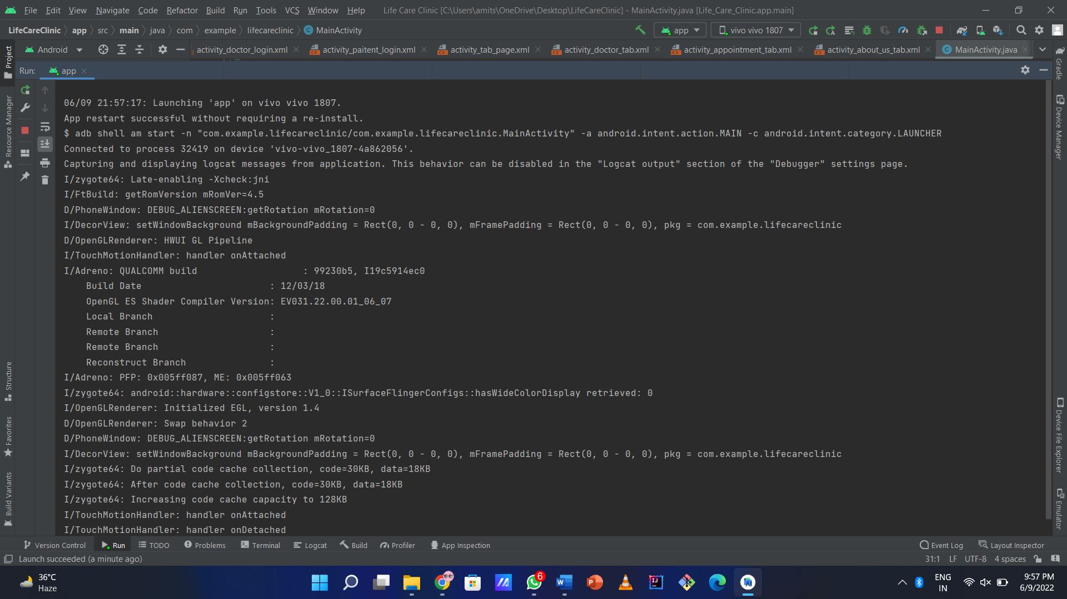

**CHAPTER-10**

**User/Operational Manual**

To Book appointment user has to first register or login and then after login and email or phone verification he/she can book appointment by clicking on the book appointment button. After clicking on it a new window will open in that particular window patient can select date and time and book the appointment

**CHAPTER – 11**

**Conclusion**

The conclusion of this application is that as we have seen all the cases like overcrowding, bad management of the appointments in the clinics and small hospitals all can be reduced to very much extent through this application. Therefore this application is a type of a application which can reduce time wastage and reduce the monetary losses for both patients and doctors.

**CHAPTER – 12**

**Future Enhancement**

Doctor appointment app is the future of modern medicine. It empowers doctors, patients and healthcare enterprises to capitalize on a simple but powerful technological device i.e the smartphone. On-demand doctor booking apps can help the patients connect to doctors instantly, share reports and get prescriptions from home.

Being a top doctor appointment app development company, we create apps that are simple and usable. Our on-demand doctor app is easily customizable to expand on the basic features like booking slots, report sharing, etc. The new elements of telemedicine like video-consulting, quick movement of reports, smart notifications, etc will make your app more appealing to every user. Packing all these features and much more, the doctor scheduling app we craft for you is going to be the most searched app in the Google Playstore and Apple App Store.

**CHAPTER – 13**

**References**

http://cms-content.bates.edu/prebuilt/hr/hr-screening-appointment-user-manual.pdf

https://www.freeprojectz.com/dfd/doctor-appointment-system-dataflow-diagram

https://www.qmatic.com/blog/appointment-systems-in-hospitals

https://developer.android.com/studio/run/emulator

https://developer.android.com/studio